**PIZZA SALES SQL QUERIES**

**A.KPI’s**

**1.Total Revenue:**



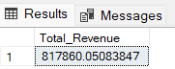

**2.Average Order Value:**



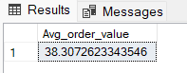

**3.Total Pizzas sold:**





**4.Total Orders:**



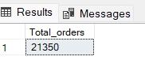

**5.Average Pizzas per order:**



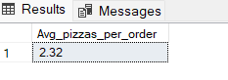

**B. Daily Trend for Total Orders**

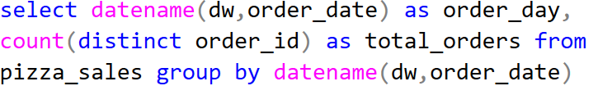

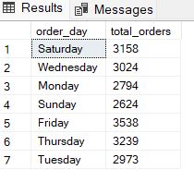

**C. Hourly Trend for Orders**

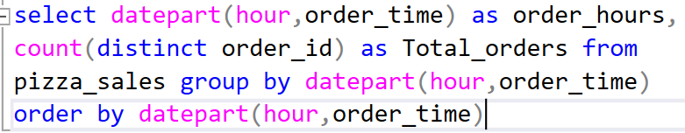

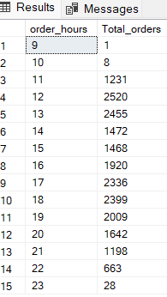

**D. % of Sales by Pizza Category**

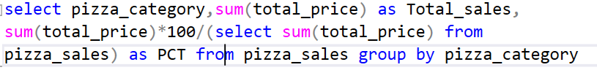

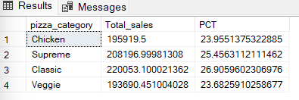

**E. % Sales by Pizza Size**

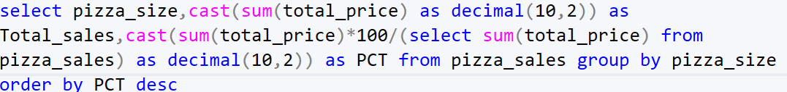

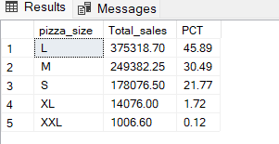

**F. Total Pizzas sold by Pizza Category**



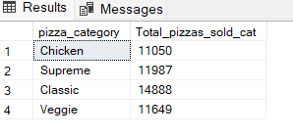

**G. Top 5 Best Sellers by Total Pizzas Sold**



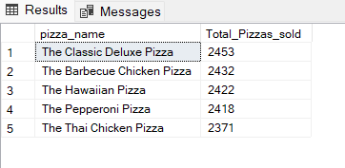

**H. Bottom 5 Best Sellers by Total Pizzas Sold**



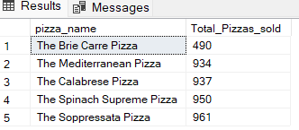

***NOTE***

**If you want to apply the Month, Quarter, Week filters to the above queries you can use WHERE clause. Follow some of below examples**

**SELECT DATENAME(DW, order_date) AS order_day, COUNT(DISTINCT order_id) AS total_orders**

**FROM pizza_sales**

**WHERE MONTH(order_date) = 1**

**GROUP BY DATENAME(DW, order_date)**

***\*Here MONTH(order_date) = 1 indicates that the output is for the month of January. MONTH(order_date) = 4 indicates output for Month of April.***

**SELECT DATENAME(DW, order_date) AS order_day, COUNT(DISTINCT order_id) AS total_orders**

**FROM pizza_sales**

**WHERE DATEPART(QUARTER, order_date) = 1**

**GROUP BY DATENAME(DW, order_date)**

***\*Here DATEPART(QUARTER, order_date) = 1 indicates that the output is for the Quarter 1. MONTH(order_date) = 3 indicates output for Quarter 3.***